

***Office of the Prime Minister***

***Directorate-Disaster Risk Management***

**NAMIBIA RURAL FOOD SECURITY AND LIVELIHOOD VULNERABILITY ASSESSMENT REPORT**

**Outcome Forecast Analysis**

**2016-2017 Consumption Year**

Covering Livelihood Zones: NACCR, NACSN, NACSS, NAFSS, NAKCS, NALMC, NAUCL and NAUCL

Financed by: Office of the Prime Minister and SADC Regional Vulnerability Analysis and Assessment

The Namibia Vulnerability Assessment Committee (NAMVAC) is comprised of:

* Disaster Risk Management Directorate
* Zambezi Regional Council
* Oshikoto Regional Council
* Omaheke Regional Council
* //Karas Regional Council
* Oshana Regional Council
* Omusati Regional Council
* Zambezi Regional Council
* Kavango West Regional Council
* Erongo Regional Council
* Erongo Regional Council
* Kavango East Regional Council
* Omusati Regional Council
* Kunene Regional Council

The NAMVAC is led by the Disaster Risk Management Directorate with technical support from the SADC Regional Vulnerability Assessment and Technical Assistance Team

|  |  |  |
| --- | --- | --- |
| **Enquiries: please contact NAMVAC Secretariat**  Disaster Risk Management Directorate  Office of the Prime Minister | Postal and courier address: | Tel. +  Fax. +  Email: |

##### Map of the country showing the livelihood zones

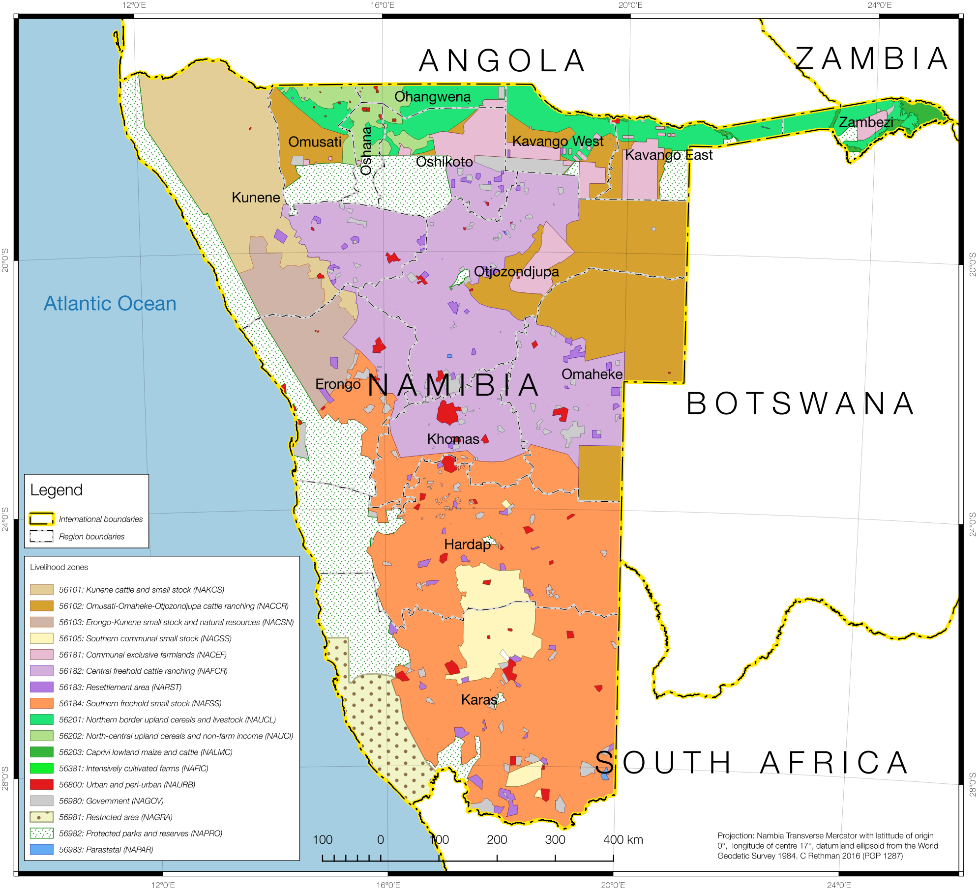**The nine livelihood zones covered in this assessment are:**

1. Kunene cattle and small stock (NAKCS) – 56101
2. Omusati-Omaheke-Otjozondjupa cattle ranching (NACCR) – 56102
3. Erongo-Kunene small stock and natural resources (NACSN) – 56103
4. Southern communal small stock (NACSS) – 56105
5. Central freehold cattle ranching (NAFCR) – 56182
6. Southern freehold small stock (NAFSS) – 56184
7. Northern border upland cereals and livestock (NAUCL) – 56201
8. North-central upland cereals and non-farm income (NAUCI) – 56202
9. Caprivi lowland maize and cattle (NALMC) – 5620

**Acknowledgements**

The Namibia Vulnerability Assessment Committee (NAMVAC) would sincerely like to extend their gratitude to the Republic of Namibia Government, through the Department of Disaster for providing transport, financial resources, some office equipment and stationary and the overall coordination of the scenario modelling of the nine livelihood zones in Namibia.

The NAMVAC would also want to extend its gratitude to all government departments, who willingly released their senior staff to participate in the three-week scenario modelling activity to improve the capacity of the NAMVAC.

Thanks are also due to both Central Government and Regional staff and surrounding areas who facilitated the meetings with village leaders and key informants and for providing secondary data that was used in the report.

The assessments conducted at village level could not have been a success if it were not for a committed and efficient Community Leadership in all the visited villages. We thank you indunas, councillors and the communities of the visited villages in all visited municipalities.

The NAMVAC also thanks the SADC Regional Vulnerability Assessment and Analysis (RVAA) programme through the Programme Management Unit (PMU) for making the whole process a success through the provision of trainers, team leaders, stationery and financial resources.

### Introduction

Since 2013, Namibia has been faced with increased occurrence of natural hazards and shocks that impact on rural livelihoods and food security conditions. Severe drought affected rural livelihoods and reduced both crop and livestock productivity. This pushed several rural households into unsustainable coping strategies including panic livestock sales at very low prices. Improvements in the 2014 rainfall situation provided a ray of hope but this has been shattered by a recurrence of severe drought in 2015 / 2016 agricultural season threatening a reversal of gains in the previous years.

In addition to the poor crop production prospects, the failed rainfall season has resulted in a severe shortage of water and pasture for livestock, low milk production and general poor body conditions for livestock. In livelihood zones where poor households depend on sale of natural resource products such as grass for thatching and crafts, the poor rainfall has resulted in reduced access to this source of income.

Food prices have significantly increased in most parts of the country and this directly impacts on very poor and poor households, some of whom purchase up to 60% - 70% of the food they consume in a normal year.

The Disaster Risk Management Directorate (DRMD) in collaboration with the Southern African Development Community (SADC) Regional Vulnerability Assessment and Analysis (RVAA) Programme is working towards strengthening food insecurity and vulnerability assessment in South Africa. Through this partnership, a number of activities have been conducted towards institutionalisation of the Namibia Vulnerability Assessment Committee (NAMVAC). The most recent activities include the updating of food security livelihood zone baselines which was conducted in February to March 2016.

The complexity and dynamic of hazards across Namibia as a country requires the vulnerability assessment system that is able to inform policy makers timely and accurately. As result of these efforts, forecast assessments of livelihoods and food security indicators’ were carried out in May 2016 in the following nine livelihood zones:

* 1 Omaheke and Otjozondjupa Cattle Ranching
* 2 Southern Communal Small Stock
* 3 Erongo – Kunene Small Stock and Natural Resources
* 4 Central Freehold Cattle Ranching
* 5. Southern Freehold Small Stock
* 6. Kunene Cattle Ranching
* 7. Caprivi Lowland Maize Cattle
* 8. Northern Border Upland Cereal and Non – Farm Income
* 9. Northern Border Upland Cereal and Livestock

NAMVAC uses the Household Economy Approach (HEA). The basic principle underlying the Household Economy Approach is that analyzing local livelihoods is essential for a proper understanding of the impact (at household level), of shocks such as drought, conflict or market changes. The Household economy analysis establishes a picture of typical, normal livelihood patterns for households in a specific livelihood zone, in order to understand a range of conditions that local communities must cope with in a normal year as its baseline assessment.

The baseline assessment also focuses on understanding the various household sources of food, income and expenditure patterns among the four wealth groups (‘Very Poor’, ‘Poor’, ‘Middle’ and ‘Better Off’) defined by community key informants. It also explores issues related to household vulnerability as well as the coping strategies and options they undertake during bad years.

The baseline information is then used as a reference point for modelling the likely effects of shocks such as drought, floods and market failure. These shocks may affect people’s ability to maintain their livelihoods or in extreme cases, they could be life-threatening. Any external response to these shocks needs to be based on the provision information and analysis, which gives solid guidance for short, medium and long term relief, recovery and development initiatives.

The purpose of the forecast scenario analysis exercise was to establish whether livelihoods of the household in the area covered by the zones have been affected, compared with the baseline outcomes. This will be used to inform policy makers and provide recommendations for appropriate policy actions.

A team of thirty six personnel, trained in vulnerability assessment and analysis methodologies, was engaged in defining problem specifications and modelling the possible effects on households. Crop failure may, for example, leave one group of households without anything to eat if crop production is their main source of food but another group may be able to cope because they have alternative sources of food and income that can make up for lost crop production.

Baseline data was used to determine the key parameters that needed to be analysed and these included crop and livestock production, prices, and government assistance programmes among others. The NAMVAC also consulted key informants within the livelihood zones and villages to seek their input and participation in the forecast analysis data collection.

This report focuses on the current agricultural season in terms of general rainfall and weather conditions, crop and livestock production and household sources of food and cash income.

The analysis combines current year monitoring data with baseline data to project the most likely scenario in the quarter of the 2016/17 consumption year.

### A Summary of the Assessment Process

The process of updating baseline livelihood profiling started in 2006 with a livelihood zoning exercise, given the significance of geography as a determinant of livelihood patterns. A livelihood zone was visited and the next step was to define the wealth groups in the livelihood zone as wealth determines options available to the household for access to food and income.

Having patterned households according to where they live and their wealth[1], the next step was to generate baseline livelihood profiles for typical households in each wealth group for a defined baseline or reference consumption year. An understanding of food access is gained by investigating the sum of ways households obtain food; that is, how much food they get from their own direct food crop production, their livestock, gifts from others, exchanges or barters and from purchases. To understand the latter, information is also collected on how much cash income is earned in a year and what essential needs are met with the earned income.

Once the baseline is established, analysis can be made on the likely impact of a shock or hazard in the current year. This involves assessing how food access will be affected by the shock, what other food sources can be added or expanded to make up for the initial shortfall, given households’ asset holdings and capacity to earn more. After all these factors are considered, final deficits emerge once households have exhausting all their coping strategies. The NAMVAC used the period April 2013 to March 2014 as the baseline or reference consumption year and therefore the current analysis reflects the impact of current problems for the forecast period of 2016 to 2017.

### The key parameters assessed in May 2016

Using the baseline profiles, key parameters for monitoring were identified in regard to food access, sources of income and prices of: food, crop, livestock, labor and non-food items. It was included items in the minimum non-staple, essential household expenditure basket, survival and livelihood thresholds.

The key parameters assessed included:

* Household access to food from own-production and how it compares this year with that in the baseline year March 2013;
* Household access to food from agricultural labour exchange and how this compares with the baseline year;
* Access to food from livestock products and how this compares with the baseline year;
* Quantities of income-activities in the current year from crop sales, livestock sales, agricultural labour, other casual labour, petty trading, access to social grants and other income activities that vary across wealth groups, compared with the baseline;
* The current prices of maize, millet, sorghum and livestock in the current year compared with baseline year prices;
* The price of items in the minimum non staple basket (soap, paraffin, matches, sugar, Tea and salt), and the essential expenditure basket (education, medical, ploughing, seed, livestock treatment, cooking oil, clothing and grinding costs).

Comparison of key parameters data for 2013 with 2014 was done and the findings from this analysis formed the current year problem specification for scenario modelling.

### Methodology

The Namibia Africa Vulnerability Assessment Committee (NAMVAC), conducts assessments and analysis using a livelihoods based analytical framework, called the Household Economy Approach (HEA), for modelling its forecasts. There are four steps in a household or food economy analysis. The first two are concerned with dividing the population into groups of households that share similar characteristics in terms of their access to food and income. The assumption underlying these two steps is that access to food and income is determined by two factors; geography and economic status (i.e. relative wealth). While geography (where a household lives) determines the options for obtaining food and income, wealth generally determines a household’s ability to exploit those options. The third step involves developing a baseline picture of food access, income and expenditure for each wealth group. The fourth and final step is to combine information on baseline access with that on hazard and response in order to generate projections of future food and income access; the process can be summarised thus: Baseline + Hazard + Response = Outcome. The HEA methodology provides an opportunity for field officers to probe during discussions while at the same time observing the surrounding and non-verbal communication signs.

The HEA methodology has been widely adopted in most Member States in the SADC Region. The methodology saves on resources and time, making it affordable and sustainable under small budgets. The methodology also attempts to maximise the use of existing information and survey data. Besides data generated using HEA, NAMVAC also uses a range of secondary sources of data such as the crop estimates from the Department of Agriculture, population projections, inflation and price data from Stats Namibia. The field exercise therefore provides an opportunity to verify secondary data with that obtained from the secondary sources as well as the villagers.

The exercise was undertaken in April and May 2016, in which the team was divided into nine groups and tasked to different parts of the zone. The villages visited were listed in the appendix of this report.

In each village, the teams held meetings with key informants. The key informants consisted of community leadership such as Headmen and any other informant agreed upon by the assessment team and the village leadership. The parameters discussed were as follows; rainfall situation, livestock and crop production, income sources and prices for food and selected non-food items.

The nine groups reconvened in Otjiwarongo for data analysis and modelling of the study findings from 08th to 19th May 2016. The analysis started by completing the forms used to collect data in the field. Then the team separated into the nine assessment groups to write and present the overall picture of the area they covered and problems faced as well as lessons learnt. The team thereafter reviewed concepts and were introduced to the analysis process.

The problem specification calculations were done manually using information collected from the field, baseline data and information from recent reports such as the rainfall, consumer price index and crop projection reports. The analysis was done by the team on the HEA spreadsheet using the baseline year data and current year forecasts.

The analysis used survival and livelihood protection thresh hold levels to estimate individuals who are below the thresholds and require policy intervention.

When households are faced with a shock such as a high increase in the price of food, the first response is to apply basic coping mechanisms such as switching from expensive to cheaper foods, followed by increasing income earning opportunities to meet the increased cost of food. When all normal coping is exhausted, the household will resort to using money meant for essential expenditure for livelihoods such as agricultural inputs, education and health care. In this case, the Household Economy Approach highlights a livelihood protection deficit. When all the money value of the livelihood protection basket is exhausted and the household is still not able to meet its minimum food energy requirement, this then entries a survival deficit in the livelihood.

***The survival deficit*** that rural households are likely to experience in 2016/17 consumption year is primarily due to their inability to purchase the balance of food required to make up 100% of their energy requirements. This is in addition to not being able to afford the livelihood protection basket. The initial analysis which considered households with access to social grants indicated that most households will not be below both survival and livelihood thresholds. Hence the analysis considered the use of two scenarios; one for the normal households without social grants whereas the one focuses on the worst case scenario of the rural households in the nine livelihood zones.

Meanwhile the ***livelihood protection deficit*** that rural households are likely to experience in 2016/17 consumption year will be due to their inability to afford purchase of some or all items in livelihood protection basket.

In each livelihood zone, the Nam-VAC has calculated survival deficits expressed as a percentage of minimum per capita energy requirement based on the requirement of 2,100 Kcal per person per day. This information is converted into staple cereal equivalent or cash for ease of interpretation.

The Nam-VAC has also calculated livelihood protection deficit by multiplying the deficit per household with total number of affected households. The total livelihood protection deficit is also converted into staple cereal equivalent to show the extent of resources required for a particular intervention or policy option.

The calculated problem specification percentages, which are the changes in the current year compared to baseline year, were entered into the analysis spreadsheet to calculate the food and expenditure deficit as well as number of people affected. The number of affected people was calculated using small area and enumeration area data for the respective areas for the 2011 Statistics Namibia Population and Household Census projections.

The results were then pooled together and a report was drafted.

### Findings / Results

#### Rainfall and Crop Production

Rainfall, the drought and their impacts on crops and livestock are the biggest geographical determinants of risk and vulnerability this year (other determinants, like food prices, are less geographically distributed). The rainfall season started during the month of October 2015 in some zones, even though the rainfall amounts recorded did not give much moisture for ploughing and planting. The zones also experienced a dry spell towards the end of December 2015 up to the end of March 2016.

The crops which were planted during the month of November 2014 for the up- or dry-land farmers in the zones were highly affected by the dry spell and a poor yield was realized.

Production estimates for the 2015/16 agricultural season shows that when compared with the baseline year, maize, millet and sorghum were the most affected crops, having been severely affected by the dry spells experienced from January to March and also affected by the drought. For major crops including maize, sorghum, beans and vegetables, this year’s yield is expected to be below 50% of the baseline year. The official data largely confirms the findings of the team. In general, the farmers anticipated lower yields (per hectare output) in the year (2015/16) when compared with the baseline year (2013/14).

**Figure 1: Normalised Differential Vegetation Index (NDV)) on the 15 May 2016**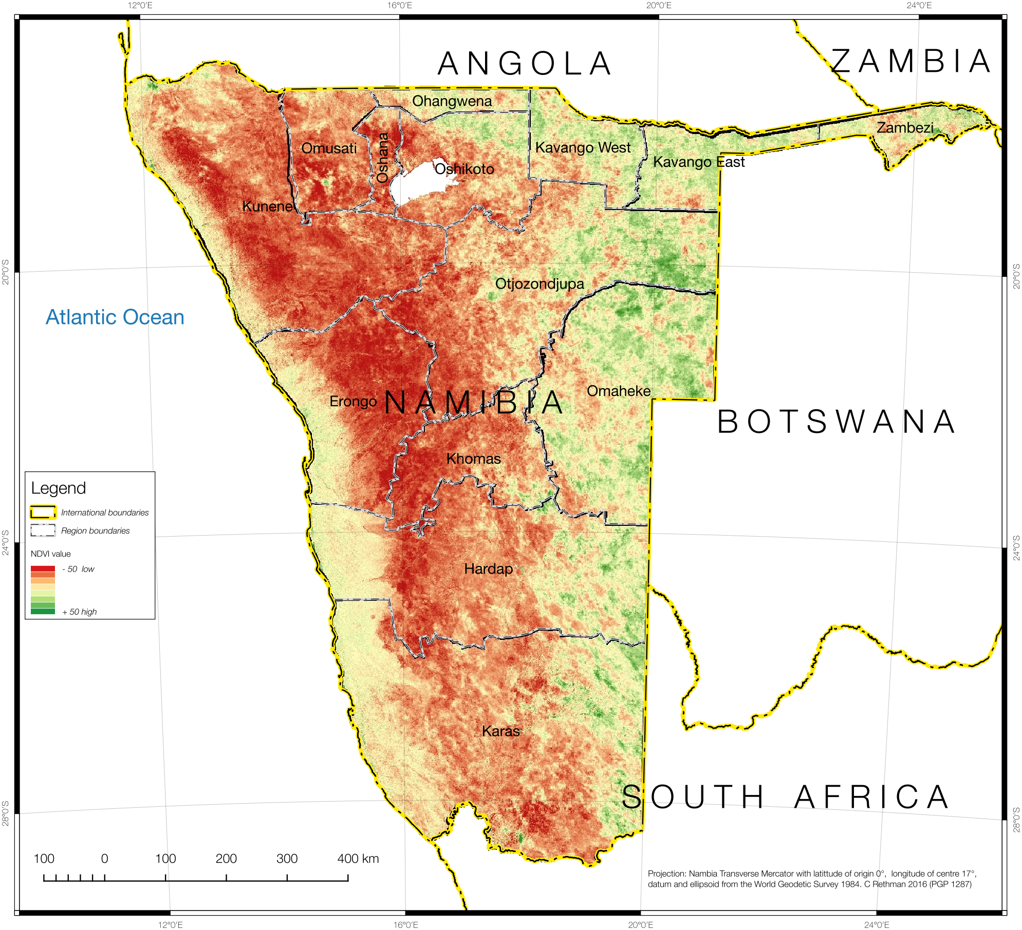

#### Analysis of affected areas

The drought and its impact on livestock was not uniformly distributed across the country; it was also not even uniformly distributed across livelihood zones, either. The team relied on secondary vegetation cover images to provide a spatial distribution on the situation with grazing and hence, livestock condition. **Figure 2** shows a particularly useful Normalised Differential Vegetation Index image, which shows the condition of rangelands at the end of the rainy season, in comparison to normal (hence the desert, which is normally dry and lacking vegetation, is even worse this season).

This image is a raster format, having been derived from satellite camera images, and was thus translated into a vector format for determining the worst affected versus lesser-affected areas.

**Figure 2: NDVI for 15 May 2016 with the indentified extreme part of the hazard area superimposed on it**

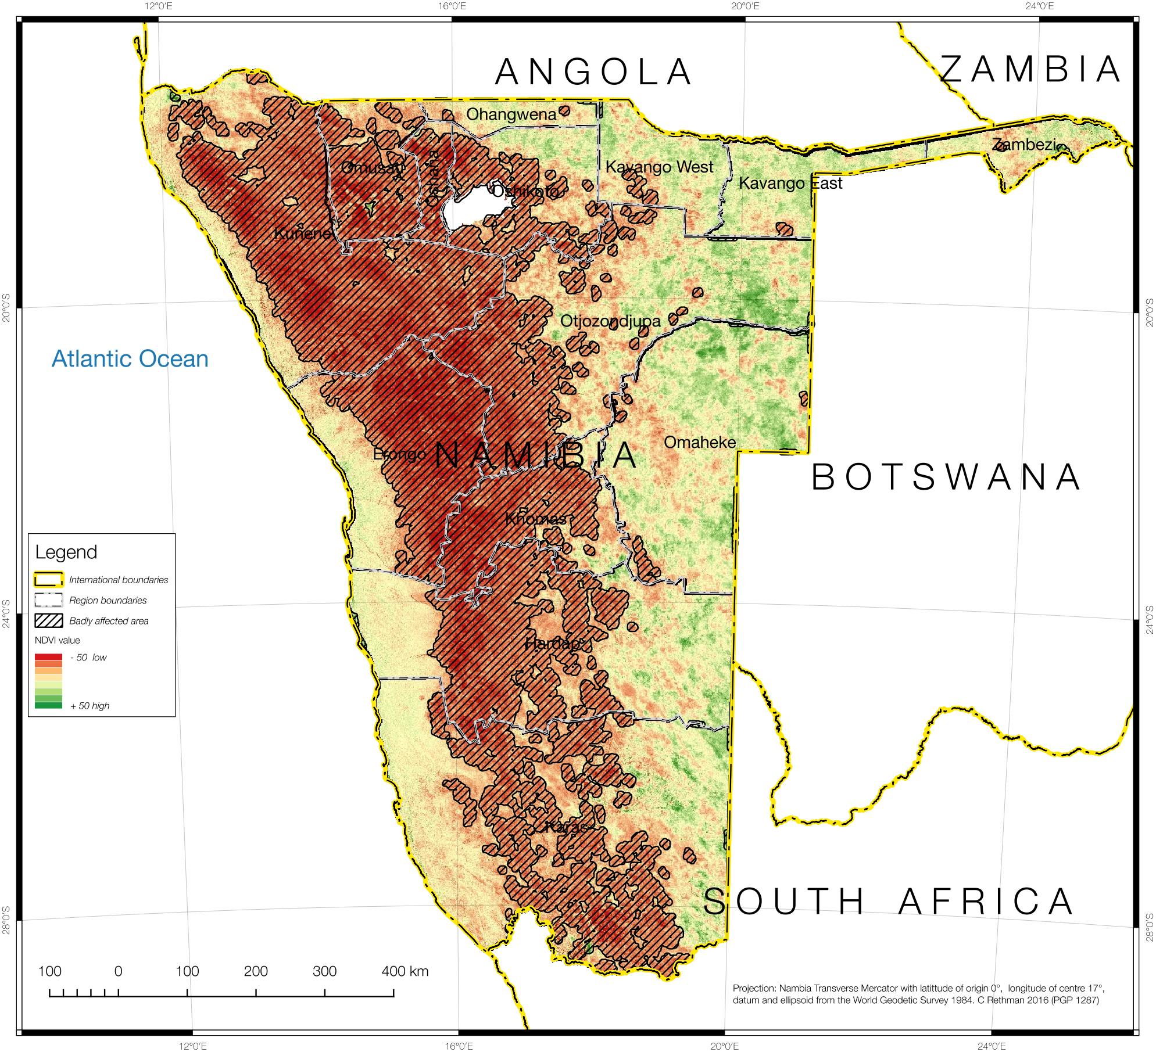

All features with the index below -20 were then combined in a spatial union (often called a 'dissolve' in some GISs), with some features – or holes – ten raster pixels or smaller being discarded. The resultant ‘badly affected’ or ‘extreme hazard’ feature is shown cross-hatched and overlaid onto the NDVI image in **Figure 3**.

The analysis of affected and unaffected populations needs to be applied to livelihoods, so this shape was overlaid onto the livelihood zones. Each of the nine livelihood zones studied, therefore, had two areas of analysis: the *worst affected* and the *badly affected* (both situations are below normal).

The extreme hazard area is shown overlaid onto the livelihood zones and cross-hatched in **Figure 4**. Notice that all livelihood zones are both covered by this exterme drought area as well as the other less badly affected area.

Figure : The extreme part of the drought hazard overlaid onto the livelihood zone map

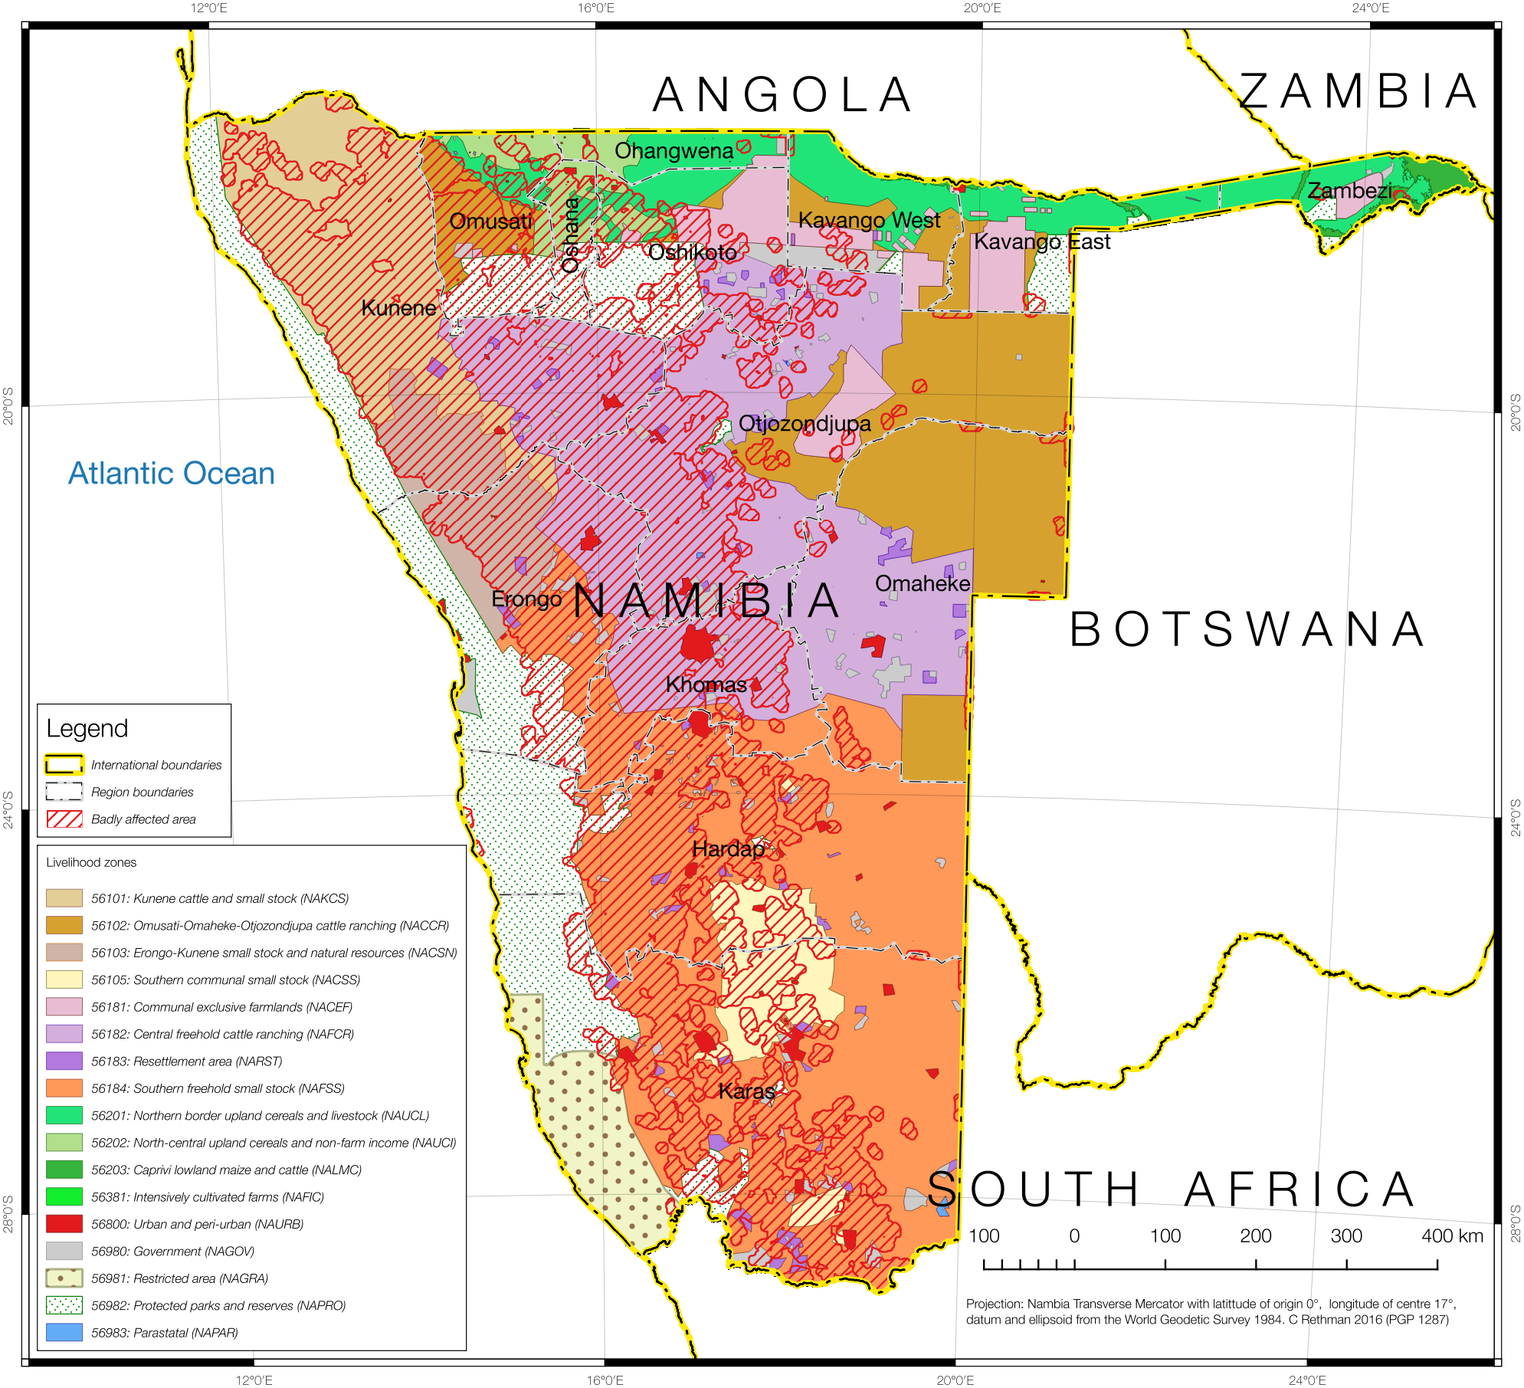

Having arrived at a picture of which livelihood zones to analyse, and having collected the data for all the problem specifications, it is also useful to determine which populations are in each of the affected areas and each of the nine livelihood zones. This is done by combining the livelihood zones in the area under study with the Enumeration Areas (EAs) from the Namibia Statistics Agency’s Census data.

The result is shown on in **Figure 5**. The NAMVAC has attributed each EA to livelihood zones based on the following rules:

1. If an EA falls entirely within a livelihood zone, then the EA is attributed to that livelihood zone.
2. If an EA straddles a livelihood zone boundary, then the EA is attributed to the livelihood zone with which it shares the greatest intersecting area (in other words, where most of the geographical area of the EA is located).

Figure : Obtaining livelilhood zone populations by attributing them to each enumeration area (EA). EAs are not cut into small units

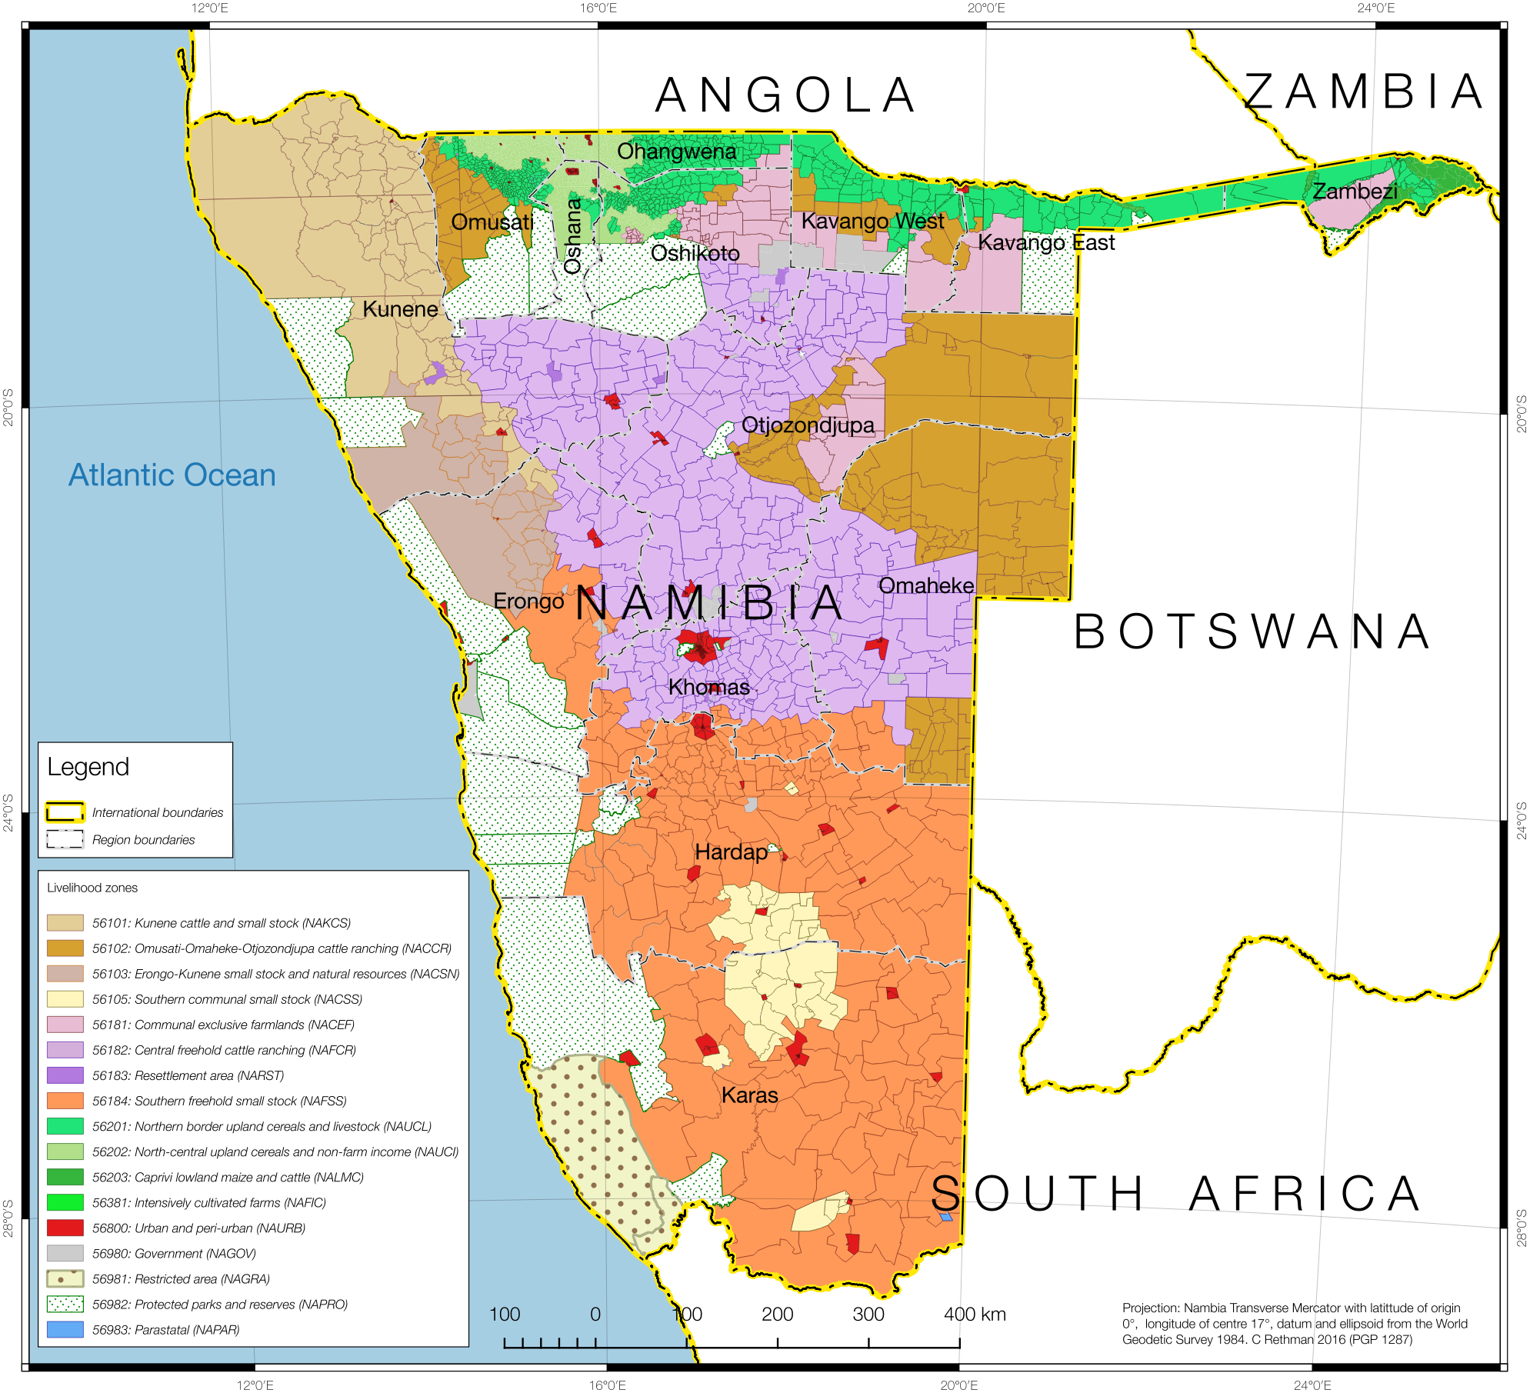

Since EAs are most very small geographical areas (the larger ones are sparsely populated), it makes sense not to chop them into smaller units. The resultant EA-livelihood zone map is shown in **Figure 5**.

The hazard area (extreme drought) is overlaid onto the livelihood zone attributed EAs in **Figure 6**.

Figure : Overlaying the extreme part of the hazard area onto livelihood zone-attributed enumeration areas for determining extreme drought-affected populations and livelihood systems

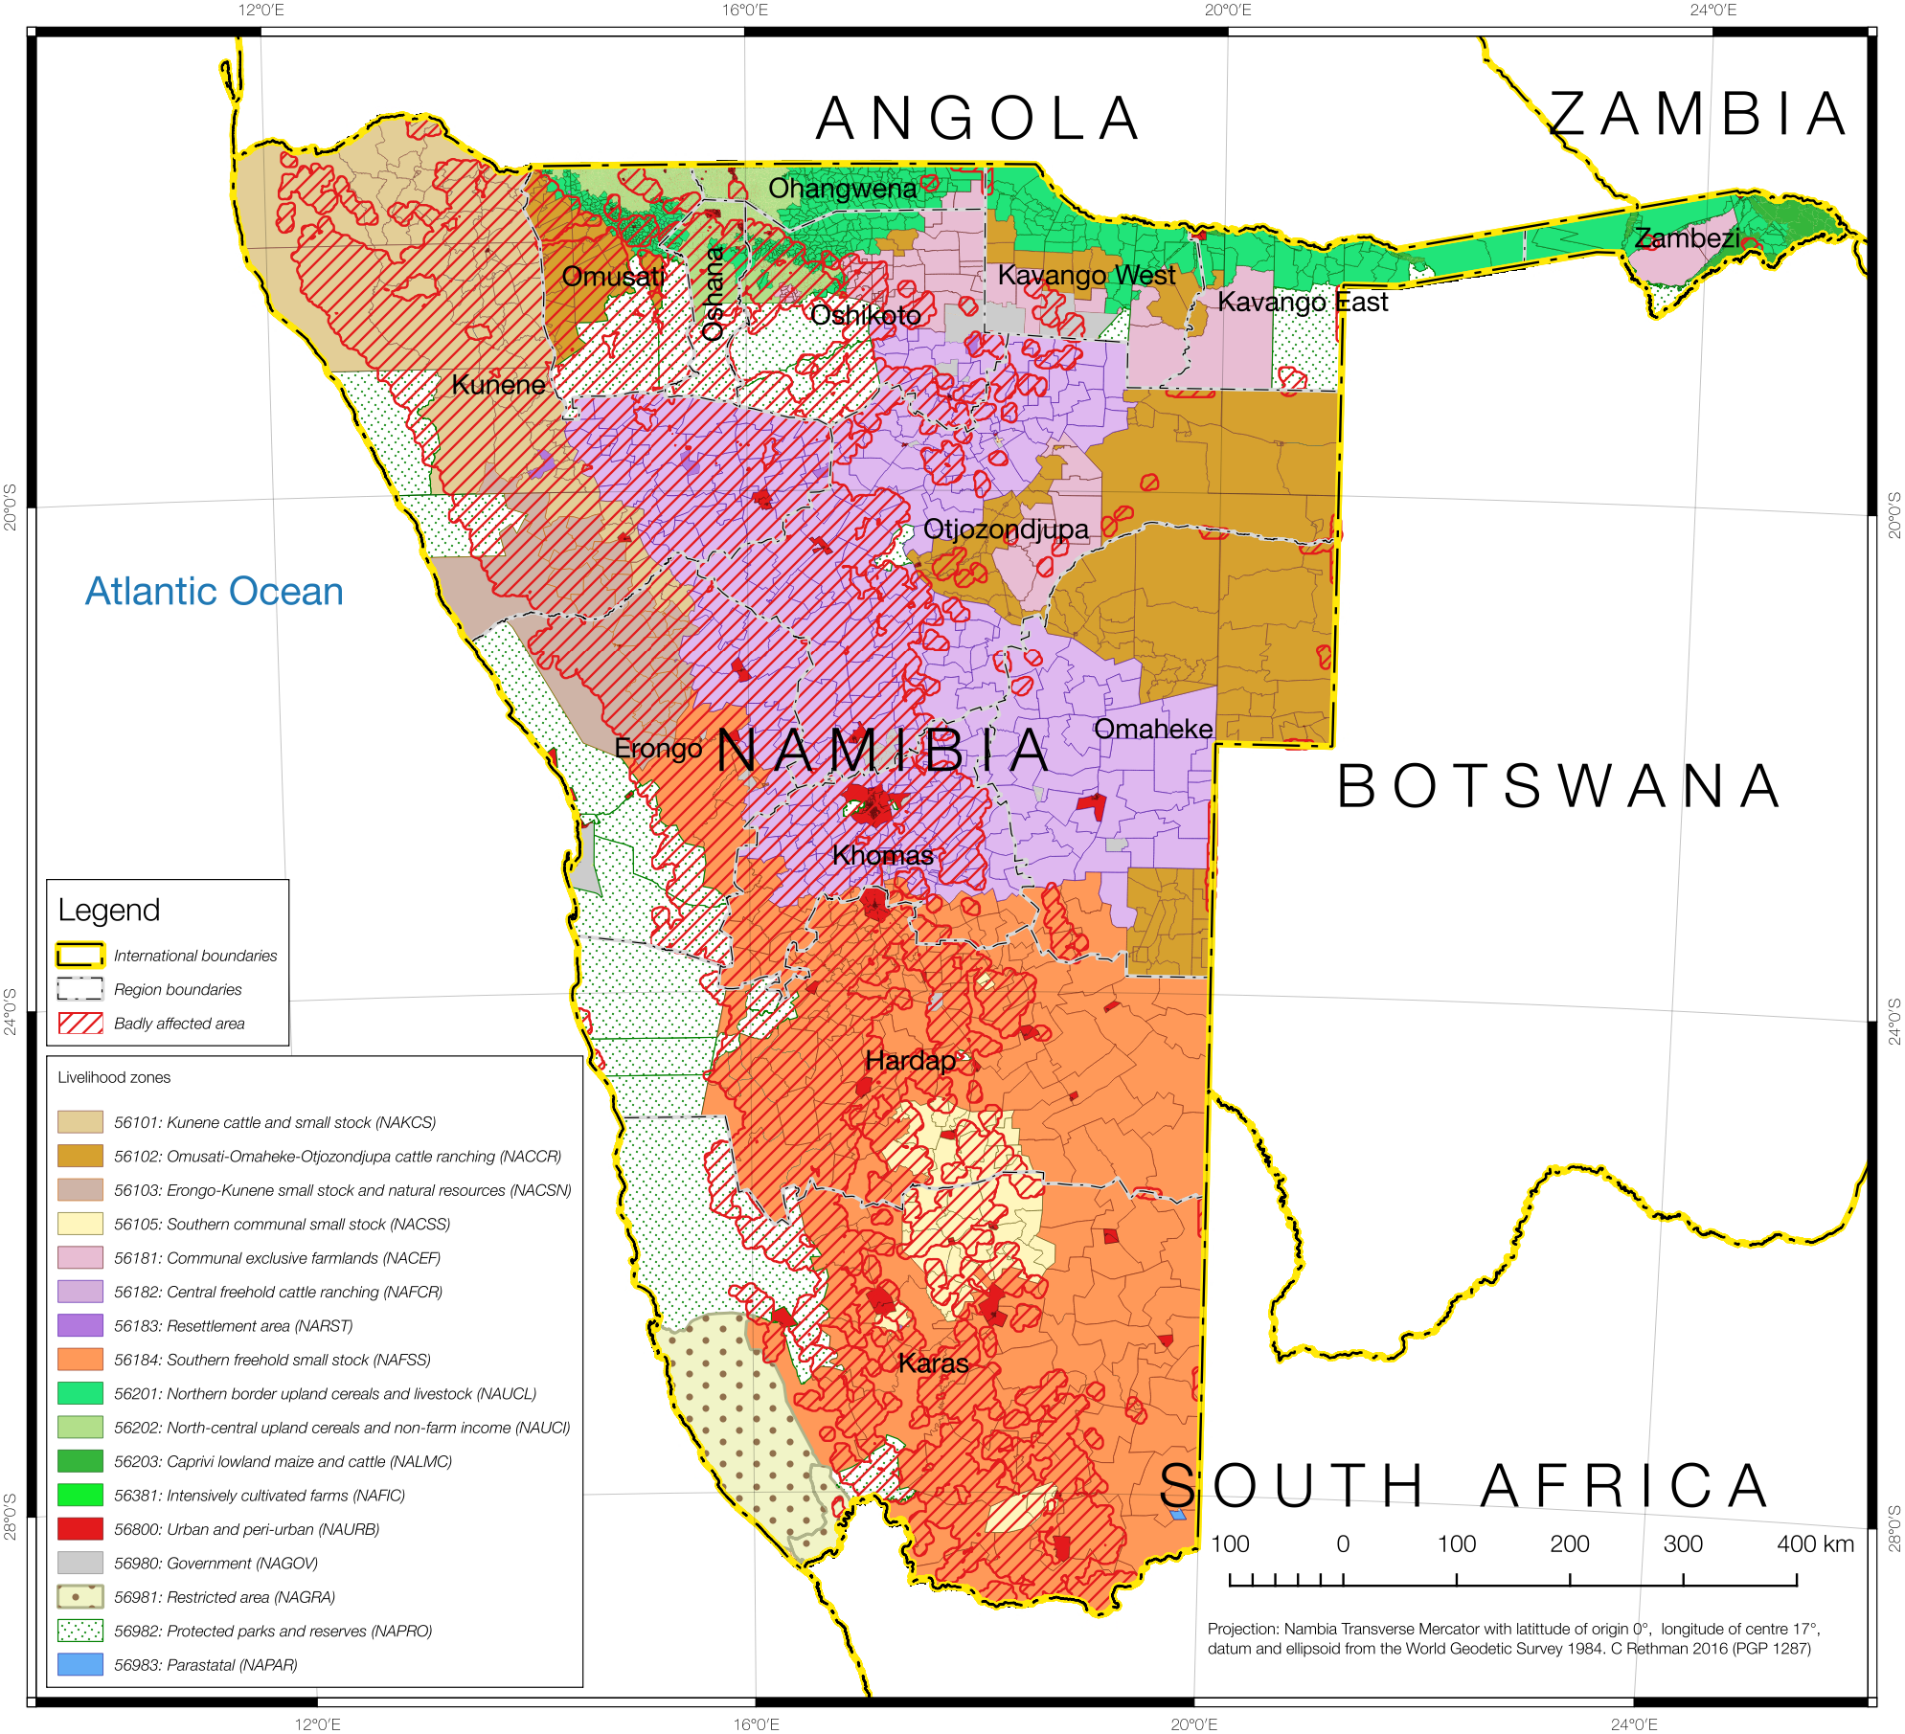

The last step to deciding analysis breakdowns is to select any EA that intersects with the affected area, which is classified badly *affected*. The remainder of EAs are classified less badly affected.

The two groups of EAs are shown in **Figure 7**.

**Figure 6: Enumeration areas for which baselines are applicable, highlighted for the extreme part of the hazard (dark red) and the less badly affected area (orange).**

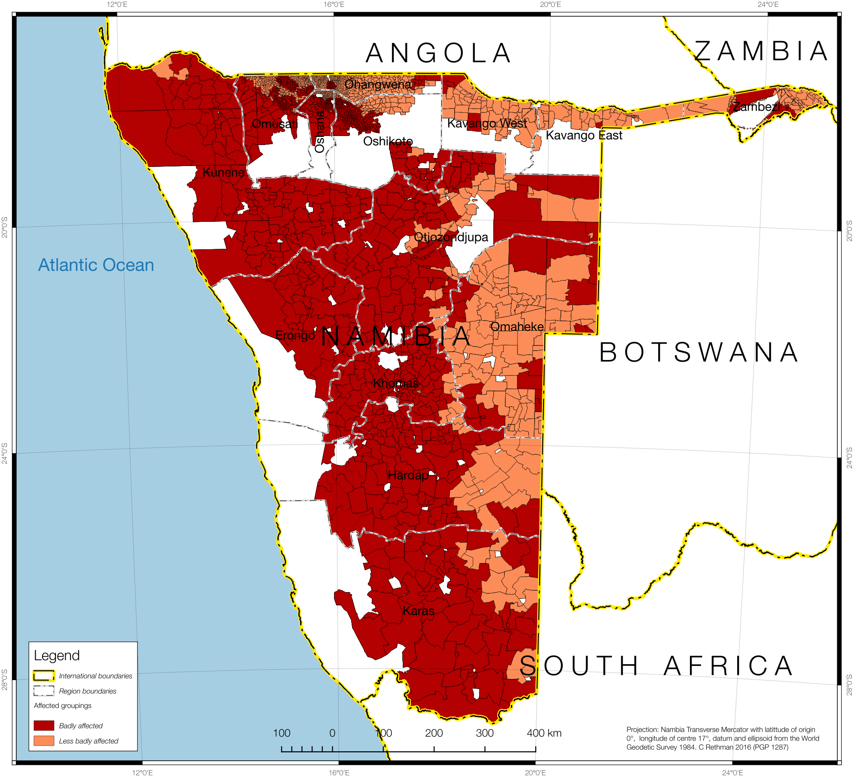

An analysis point of view is presented in **Figure 8**: this shows the EAs and their associated livelihood zones that are in the badly affected area, overlaid onto the original NDVI image.

Calculating the populations in each of the constituent areas is then possible:

* The livelihood zone the population belongs to;
* The administrative area (region, constituency) the population falls under (this is contained in the EA code), and;
* Whether the population is in the affected area.

Care needs to be taken to ensure that population projections from the 2011 census to today’s numbers are included. These can then be summed and organised by their administrative areas such as regions and constituency. A pivot table is the simplest way to achieve this cross-tabulation. This is discussed later in the report and presented in **Table 3.**

**Figure 7: The EAs in the badly affected hazard area, attributed to their livelihood zones, and overlaid onto the original NDVI image (EAs not shown include less badly affected and non-analysis areas such as national parks, urban centres, etc.).**

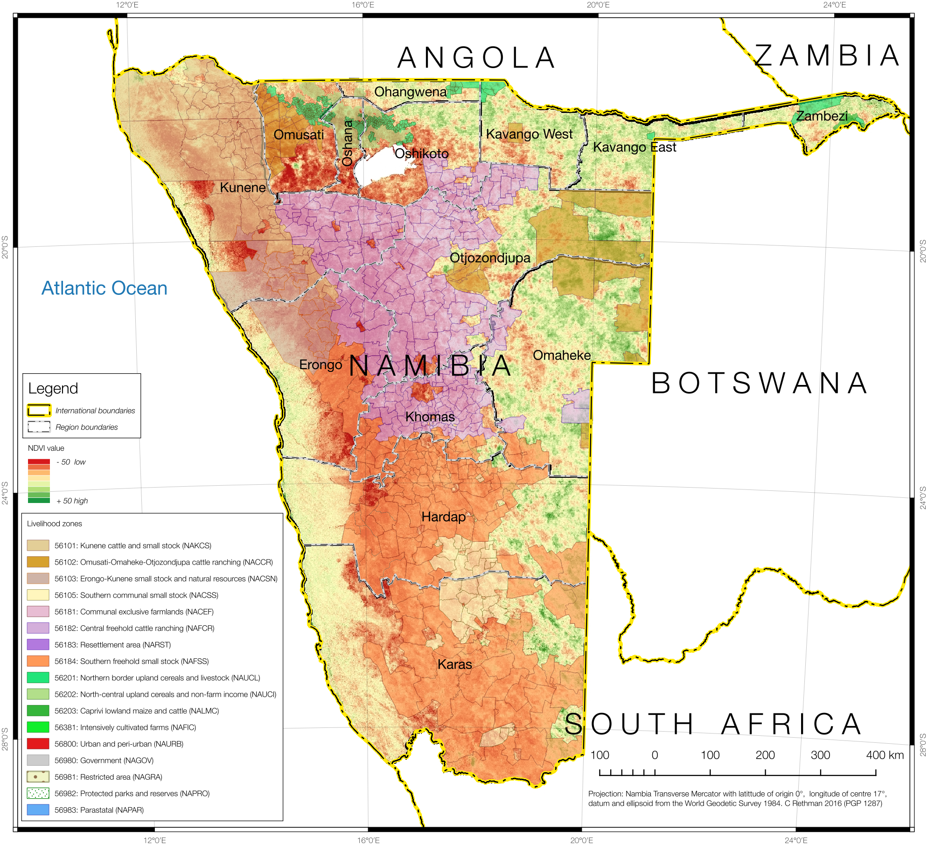

### *It must be emphasised that drought is only one type of hazard;* there are other kinds of hazards affecting people such as economic or prices changes. Hence, even people living in non-drought areas may still be at the same risk of food insecurity because of these other factors. Similarly, some people that exposed to a certain kind of hazard may not be vulnerable to it (for example, people earning a salary will likely not be as vulnerable to drought as people who practice farm). This means that not all people listed in the above Table I are necessarily at risk. This will be explored in more detail in the next sections, by studying each livelihood system and exploring the impacts of the various changes in environmental and the economic situations for different wealth groups.

#### Livestock prices

Cattle numbers have decreased by about 5% -10% from the baseline and this is attributed to the dry spells, which resulted in livestock loss. However, the price of a bull in the current year has increased by 10% over baseline average price of N$4000.

#### Agricultural income

Due to area planted by the middle and better off households within the zones, agricultural income activities were available in the current year although farming areas were also affected by the dry spells. Overall, compared with the baseline year, availability of agricultural labour opportunities was considered normal. The price for agricultural labour went up by about 5% over baseline (2013-2014) prices.

#### Public Works Programme

The number of people employed through this program is almost the same as the baseline year. The wages obtained by households involved in this program slightly increased by less than 3 per cent.

#### Staple Food Purchase Price Changes

Staple prices have increased by about 25% -29% from the baseline and this is attributed to the dry spells, which resulted in crop failure. However, the price of maize meal in the current year has increased by 48% over baseline average price.

Purchase prices of staple food commodities (maize meal, sorghum, bread and rice) are projected (by April 2017) to have increased by around 29% from that of the baseline year (May 2013 to April 2014) in Namibia. This is a problem specification of 129% and it is applied to all nine livelihood zones. This projection is based on the previous price changes and on forecasts for inflation generally. This may or may not change in reality—a lot will depend on the domestic supply situation, the country's import requirements and the position with the Namibian Dollar position against the major currencies.

In rural areas of the country, all livelihood zones, there are fewer outlets and distribution costs mean that staple prices in the villages are higher than in towns or cities. Traders who *increase* their prices of food commodities *beyond that of increases* elsewhere are seen as exploiting vulnerable rural communities. This is because ‘very poor’ and ‘poor’ households in these zones purchase 50–70% of their annual food requirements, increases in staple prices seriously affects their access to food. This is a key parameter for NAMVAC to monitor.

#### Other Food Items' Purchase Price Changes

The cheapest way for people to obtain the food energy they need is through staple, usually maize. In a situation of outright starvation (a famine situation) it may be necessary for an analyst to focus on this staple acquisition but in Namibia analysts are more concerned with livelihood threshold, poverty and inequality—which implies that quality of life and living standards are more of the issue than mass shortage of food energy.

A diet that is confined to staples is not healthy at all and diversity is essential for people to obtain all the nutrients they require, providing them with the capacity for a productive and dignified life.

The non-staple items are projected to increase at the country’ non-cereal food inflation rates, with the projection for the coming months based on the overall inflation projections. The resultant problem specification for the 2015-2016 consumption year for non-staple foods is 130%, or an increase in prices of 30% since the baseline year (April 2013 to March 2014). This was applied to all nine livelihood zones.

Lastly, there are important *investments* that households must make each year if they are to have sustainable livelihoods. This means that they must spend on maintenance of all their capital (human, social, physical, environmental and financial) if they are to be able to develop themselves further and withstand or recover from future livelihood hazards. This expenditure therefore includes livelihood-specific investments in inputs for agriculture or business activities (including labour), educational investments, health and nutrition investments. Critically, these investments usually have a knock-on impacts from one wealth group to another; for example, money spent on labour hire by the better-off adds significantly to poorer households' incomes.

#### Food availability

Generally, food is available in all retail outlets, such as the big grocery chain stores such as Pick ’n’ Pay, Spar, and Shoprite, as well as the smaller local stores. There are some areas within the zones, including the livestock based livelihood zones that need monitoring as they will lose livestock this coming season if the rains are insufficient because of the lack of pasture for animal grazing.

### Analysis of the livelihood zones

Analysis was done for both the drought-affected and unaffected areas of each livelihood zone. Both unaffected and affected areas had the same or very similar price problem specifications; the differences being in crop and livestock production.

Affected areas fared slightly worse than unaffected areas but the difference was not substantial, highlighting the relative unimportance of agriculture as a source of food and income, compared with social grants, paid employment and small businesses. The hazards that are more likely to have an impact on livelihoods and consumption levels are therefore those that affect these incomes and expenditure, such as high borrowing rates (affecting the government's ability to deliver on social grants, as well as loans for starting businesses), high food purchase prices and the lack of opportunities for work (agricultural, domestic and short-term contracts, such as construction).

The poorest households invest the least in agriculture; they depend on social grants and casual work as their main source of income. The casual work may be domestic, construction or agricultural—in the case of the latter it may be local (within the village or on commercial farms). The *direct* impact of the drought on them has therefore been the least—*indirectly*, they may suffer from reduced work opportunities. This may seem counter-intuitive to readers schooled in reducing village economies to “subsistence agriculture”. Similarly, the better-off have either full time employment or a small business that cushions their livelihood from losses due to drought or weather hazards. It is actually the 'middle' households who are more dependent on agriculture but lack this cushion and who are most vulnerable to this kind of hazard.

The very poor and poor households do depend heavily on the market for their food and, with the kind of income activities in which they engage in such as weeding work, harvesting work, low-level petty trading, craft selling and domestic work already stretched to the limit, opportunities for them to expand their income are minimal. Hence, their vulnerability is to price changes and shocks.

Wealthier households may dispose of assets or switch non-essential expenditure to food purchases and essential expenditure.

In the baseline year, 'very poor' and ‘poor’ households in almost all livelihood zone have both survival and livelihood deficits, especially for households which do not have access to social grants. In an analysis of this kind in Namibia, we are not as interested in starvation or in desperate life-threatening mass deprivation. This is because living standards and the opportunities for the rural populations in Namibia enable them to escape the worst conditions. This is especially important when viewed over time, factoring in impoverishment brought on by external events to households' livelihoods. This is because the comprehensive safety net and social grant system ought to cover the bare minimum needs for all citizens, automatically preventing ultra-poor conditions or extreme deprivation for the great majority of people. However, the grant system is designed around needs for an *average year*, while this assessment studies the impact of ephemeral change, from one year to the next. Therefore, it is not surprising that there are *no food energy deficits* for households with access to social grants in any wealth group in any livelihood zone. Much more useful information can be obtained by considering a whole basket of food and non-food goods and investigating physical and economic access to them.

The NAMVAC does this by converting all production (including production that is consumed directly) into a cash equivalent, based on what it would cost to have purchased the items consumed directly if they had not been produced by the household, and then adding the cash values together over a whole year to obtain an *annual total income*.

The analysis based on the field assessment and the problem specifications indicated that very poor and poor households that indicated social grants as their main source of income and have access to social security grant especially pension will not have any survival deficit in the 2016/17 consumption year. This contributes to 11 per cent of the households based on NAM Stats Agency’s secondary data. However, households within very poor and poor wealth groups without access to social grants are at risk of food insecurity in the 2016/17 consumption year. The problem specifications and deficits of the households without access to pension grant within the livelihood zones were then summarized into two scenarios as specified in the **table 1** and **table 2** below;

**Table 1: Livelihood zones case scenarios**

|  |  |
| --- | --- |
| **Normal case scenario** | **Worst case scenario** |
| * Fairly normal crop production: 80% to 100% of normal (-20% to 0%) | * Very bad crop production: less than 40% of Baseline (-80%) |
| * Agricultural work opportunities: 80% to 100% (-20% to -0%) | * Bad agricultural work opportunities: 30% to 60% of Baseline (-70% to -40%) |
| * Other work normal | * Other work normal |
| * Livestock production not as severely affected | * Livestock production affected by earlier sales and poor condition |

**Table 2: Livelihood zones survival deficits for household without access to pension grant**

|  |  |  |  |  |  |  |
| --- | --- | --- | --- | --- | --- | --- |
| **Livelihood zone** | **Normal Case Scenario deficits** | | | **Worst Case Scenario deficits** | | |
| **With Social grant** | **Without Social grant** | **Number of deficit months** | **With Social grant** | **Without Social grant** | **Number of deficit months** |
| Omaheke and Otjozondjupa Cattle Ranching | 0% | 9% | 1.0 | 0% | 18% | 2.0 |
| Southern Communal Small Stock | 0% | 5% | 0.6 | 0% | 6% | 0.7 |
| Erongo – Kunene Small Stock and Natural Resources | 0% | 0% | 0.0 | 0% | 7% | 0.8 |
| Central Freehold Cattle Ranching | 0% | 0% | 0.0 | 0% | 5% | 0.6 |
| Southern Freehold Small Stock | 0% | 0% | 0.0 | 0% | 3% | 0.4 |
| Kunene Cattle Ranching | 0% | 19% | 2.3 | 0% | 21% | 2.5 |
| Caprivi Lowland Maize Cattle | 0% | 35% | 4.2 | 0% | 35% | 4.2 |
| Northern Border Upland Cereal and Non – Farm Income | 0% | 24% | 2.9 | 0% | 75% | 9.0 |
| Northern Border Upland Cereal and Livestock | 0% | 11% | 1.3 | 0% | 63% | 7.6 |

Table 2 indicates the expected deficits based on the two scenario and the number of months requiring interventions in the livelihood zones. The detailed populations affected and requiring both humanitarian and developmental interventions are summarized in table 3.

#### Summary of Deficits in Livelihood Zones and Administrative Areas

The household deficits for each region is combined with population breakdowns by livelihood zones and administrative area. The tables below presented this in cross-tabulated format: livelihood zones, containing population numbers affected and total deficits, are arranged in columns, while regions are arranged in rows. Data for an administrative area appear where it overlaps with a livelihood zone and it is experiencing a deficit for at least one wealth group. The results show that 595,839 people in Namibia are below their survival threshold and require both humanitarian and developmental interventions in the consumption year 2016/17. The highest number of the population with the deficit is in North Central Upland Income and Non-Farm Income livelihood zone (227,916), seconded by Northern Border Upland Cereals and Livestock livelihood zone (148,632). The results also show that Caprivi Lowland Maize and Cattle livelihood zone has 56,203 people below the survival threshold based whereas Kunene Cattle and Small Stock livelihood zone has 25,827 people below the survival threshold based the outcome forecast assessment. The lowest population (3095) is registered in Erongo-Kunene Small Stock and Natural Resources livelihood zone. The results show that households that are in livelihood zones which practice both crop and livestock production have been hit worst by the drought and dry spells in Namibia.

**Table 3: Populations and deficits below the survival and livelihood thresholds (Survival Deficits are in Metric tonnes of maize)**

|  |  |  |  |  |  |  |
| --- | --- | --- | --- | --- | --- | --- |
| **Regions** | **56101: Kunene cattle and small stock (NAKCS** | | **56102: Omusati-Omaheke-Otjozondjupa cattle ranching (NACCR)** | | **56103: Erongo-Kunene small stock and natural resources (NACSN)** | |
| **Pop with Survival Deficit** | **Survival Def Total** | **Pop with Survival Deficit** | **Survival Def Total** | **Pop with Survival Deficit** | **Survival Def Total** |
| Caprivi |  |  |  |  |  |  |
| Erongo | 429 | 0.0803 |  |  | 2101 | 0.2232 |
| Hardap |  |  |  |  |  |  |
| Karas |  |  |  |  |  |  |
| Kavango |  |  | 2305 | 0.2866 |  |  |
| Khomas |  |  |  |  |  |  |
| Kunene | 25398 | 4.7488 |  |  | 994 | 0.1055 |
| Ohangwena |  |  |  |  |  |  |
| Omaheke |  |  | 10487 | 1.2992 |  |  |
| Omusati |  |  | 4774 | 0.5664 |  |  |
| Oshana |  |  |  |  |  |  |
| Oshikoto |  |  | 1005 | 0.1206 |  |  |
| Otjozondjupa |  |  | 13259 | 1.6063 |  |  |
| **Grand Total** | **25827** | **4.8291** | **31830** | **3.8791** | **3095** | **0.3287** |

|  |  |  |  |  |  |  |  |  |  |  |  |  |  |  |
| --- | --- | --- | --- | --- | --- | --- | --- | --- | --- | --- | --- | --- | --- | --- |
| Regions | 56105: Southern communal small stock (NACSS | | 56182: Central freehold cattle ranching (NAFCR) | | 56184: Southern freehold small stock (NAFSS) | | 56201: Northern border upland cereals and livestock (NAUCL) | | 56202: North-central upland cereals and non-farm income (NAUCI) | | 56203: Caprivi lowland maize and cattle (NALMC) | | Total Pop with Survival Deficit | Total Survival Def Total |
| Pop with Survival Deficit | Survival Def Total | Pop with Survival Deficit | Survival Def Total | Pop with Survival Deficit | Survival Def Total | Pop with Survival Deficit | Survival Def Total | Pop with Survival Deficit | Survival Def Total | Pop with Survival Deficit | Survival Def Total |  |  |
| Caprivi |  |  |  |  |  |  | 20121 | 5.3047 |  |  | 16190 | 5.2534 | 36311 | 10.5581 |
| Erongo |  |  | 4516 | 0.4961 | 4188 | 0.2878 |  |  |  |  |  |  | 11234 | 1.0874 |
| Hardap | 1943 | 0.1455 |  |  | 8039 | 0.4584 |  |  |  |  |  |  | 9982 | 0.6039 |
| Karas | 3014 | 0.2238 |  |  | 6736 | 0.4443 |  |  |  |  |  |  | 9750 | 0.6681 |
| Kavango |  |  |  |  |  |  | 28978 | 7.5216 |  |  | 60813 | 19.7385 | 92096 | 27.5467 |
| Khomas |  |  | 6124 | 0.6785 | 1215 | 0.077 |  |  |  |  |  |  | 7339 | 0.7555 |
| Kunene |  |  | 6728 | 0.7395 |  |  |  |  |  |  |  |  | 33120 | 5.5938 |
| Ohangwena |  |  |  |  |  |  | 27178 | 7.122 | 74563 | 24.1391 |  |  | 101741 | 31.2611 |
| Omaheke |  |  | 7643 | 0.9604 | 925 | 0.0588 |  |  |  |  |  |  | 19055 | 2.3184 |
| Omusati |  |  |  |  |  |  | 38990 | 14.6589 | 66624 | 23.7546 |  |  | 110388 | 38.9799 |
| Oshana |  |  |  |  |  |  | 4788 | 1.9942 | 44362 | 16.875 |  |  | 49150 | 18.8692 |
| Oshikoto |  |  | 4954 | 0.5475 |  |  | 28577 | 10.27 | 42367 | 18.212 |  |  | 76903 | 29.1501 |
| Otjozondjupa |  |  | 25511 | 2.9062 |  |  |  |  |  |  |  |  | 38770 | 4.5125 |
| **Grand Total** | **4957** | **0.3693** | **55476** | **6.3282** | **21103** | **1.3263** | **148632** | **46.8714** | **227916** | **82.9807** | **77003** | **24.9919** | **595839** | **171.9047** |

### Conclusion

In the current year, May 2016 to March 2017, households face problems with the current drought, including reduced food production, reduced opportunities for income, increases in prices of food and increases in prices of other essential household items. This impacts on the poorest households the most.

The ‘very poor’ households in all zones rely mostly on purchases (an average of 85% of their total annual food energy intake) and this makes them vulnerable to food price increases. The combination of high food and other commodity prices, constrained work opportunities (especially through reduced availability of both agricultural labour and domestic labour opportunities), augmented somewhat by poor crop production in May 2016, reduces household capacity to access quality food and a decent standard of living, defined by the livelihood protection threshold. In the North Central Upland Cereals and Non-Farm Income and the Northern Border Upland Cereals and Livestock livelihood zones, 'very poor' and ‘poor’ households are living below the survival threshold. Although the same outcomes exist in the baseline as well, the *margins of deficit have increased this year in a number of livelihood zones due to the effect of both drought and dry spells*.

Approximately 595,839 people are below the survival threshold and their accumulated survival food gap in maize equivalent is 171.9047 metric tonnes.

### Recommendations

1. The government should consider an assistance package for the ‘very poor’ households which are likely to miss some of their livelihood entitlements in the coming months. This could be in the form of scaling up social relief grants to increase household incomes and developmental interventions that strengthen the livelihood productive assets;
2. The Extended Public Works Programme (EPWP) should be targeted to the very poor and poor households so as to increase the available employment slots, hence improving the frequency a household can benefit from the programme in a year;
3. The current NAMVAC projections are based on current conditions such as current price of maize meal. An efficient monitoring system especially for the price of maize meal is required to be able to analyse the likely impact of further price increases on household access to food;
4. There is a high potential to increase household incomes through irrigation of vegetable production which is plentiful in some zone by providing access to water for production through dams / lakes and extended pipe system especially during the peak season. There is a need for further investigation of this potential medium- to longer-term economic intervention in the area;
5. There is a need to restock livestock of households in the affected areas and also provide fodder;
6. Improve access to community micro-financing for job creating opportunities

1. Wealth is defined in terms of asset holdings and incomes